ATA CARNET- THE PASSPORT FOR GOODS
An International Customs Facilitation Scheme

IMPORTANT NOTES
The ATA Carnet is a temporary admission document which acts as a ‘PASSPORT FOR GOODS’ for three main categories of the goods:

- Commercial samples - goods to be shown or demonstrated to potential buyers i.e. jewellery, clothing, manufactured goods etc
- Exhibition goods - goods for presentation or use at trade fairs, shows, galleries or similar events
- Professional equipment (tools and equipment required to perform a commercial activity abroad, goods for testing and evaluation, theatrical effects, orchestras, racing vehicles*, broadcasting equipment, specially adapted vehicles** etc). Horses for racing purposes, commercial shows or breeding. Professional equipment must be used by, or under the personal supervision of the holder

*Carnets can only be issued for racing vehicles that are transported to the destination under transport contract (i.e. by haulier or individual that received payment for this service). Such vehicles can only be used on a dedicated race-track or on the roads closed to public. If the vehicle is road worthy and is being driven to the country of destination by the owner, then the Carnet may not be required (the same applies to personal vehicles being towed or transported by the owner (i.e. motorbike transported to EU in a van by the owner; car being towed behind a motorhome vehicle driven by the owner etc).

** Specially adapted vehicles can be driven on public roads and include any vehicle with permanently fitted equipment (i.e. broadcasting vans, exhibition trailers, water filter trucks etc)

Carnet can be used for a trip covering more than one country and includes numerous exits and re-entries in the country of origin during the period of the validity of the document. This validity can never exceed one year. Temporary admission under cover of ATA carnets applies to goods, which will be re-exported in the same state in which they were imported.

A Carnet may not be used for:

- Goods to hired out (or left unattended) abroad for financial gain*
- Perishable or consumable items (as they would not normally be re-exported)
- Goods which are temporarily exported for processing or repair**
- Goods used as a means of transport**
- The exportation of unaccompanied goods, or by post**
- Foreign goods temporarily imported into the UK
- Equipment to be used for the exploitation of natural resources (i.e. gas or oil drilling) **

*Carnet goods must be used by or supervised by the Holder whilst abroad. Leaving the goods unattended can only be permitted if the host customs agree to this in advance. Furthermore, any goods that will be used to provide chargeable services to public i.e. catering trucks selling food and drinks, fairground rides etc require advance notification to the host tax authorities to ensure that any income generated from the activity is declared correctly.

**Receiving customs may grant a higher facility, at their discretion, and permit the goods to be used in a manner not specified by the Convention. The applicant would need to obtain their approval before applying for a Carnet.

WHAT INFORMATION WILL I NEED TO PROVIDE

- Intended use for the goods
- Itinerary (the number of exits from the UK, visits to and transits through each country)
- Name of the person that will be travelling with the goods (if known)
- Description of the goods that will be temporarily exported. All the goods must be individually itemised with each item having its specific description (i.e. make, serial number), weight and value to facilitate Customs identification and prevent substitution of goods. Only the items with identical description can be grouped together
- Packaging cannot be used for describing goods i.e. “box of”, “bag of” etc. are not allowed. You can, however, state that the described item is packed in a bag or a box etc i.e. “set of Canon Camera lenses
80-200mm, s/n 1234, packed in a box”)

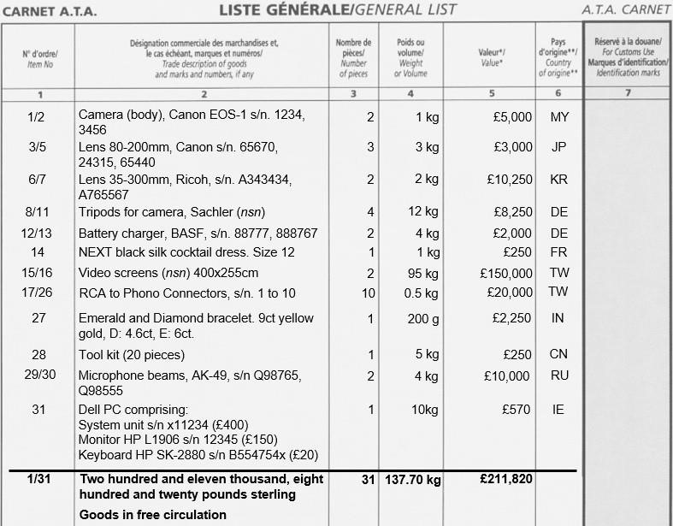

Cables – cables can be described as “set of cables” with number of pieces being 1

Toolkits – toolkits can be itemised as “toolkit” and must show weight. If the value of the toolkit is higher than £150.00 the description must also state the no of pieces

All electrical items require serial numbers to be stated (if the item does not have one or it is illegible, then state NSN at the end of the description)

Values declared must be retail values for new items (or if the goods are used, then state replacement value).

FURTHER INFORMATION ON SPECIFIC GOODS TYPES

Boats
Make, model, length, registration number (if applicable). Outboard engines as well as any other non-standard equipment must be itemised separately. Boats for personal use, transported by the owner do not need a Carnet (unless going to an official competition, exhibition or similar commercial event)

Books
Title, Author and publisher must be stated

Cinematography
All films must give titles and footage.

Clothing
Must say what the garments are i.e.: jacket, dress, skirt with as much details as possible i.e. brand, colour and style number

ATA Carnets for unfinished bespoke suits taken abroad for fitting can only be issued for Switzerland. Temporary admission and Return Goods Relief (RGR) should be utilised for exportation to any other country, as long as the suits do not increase in value + are not processed in any way whilst abroad

Concert / musical equipment (non- electrical instruments)
Generic description, make, model and serial number (if applicable)

Display stands
For panels, give sizes. If knockdown stands give either trade name, e.g. Marler Hayley and serial number with area and weight of stand when erected and at exhibition site. OR full breakdown and size of each panel (photographs useful). Note – if the holder is taking stands abroad to be built for the exhibition and this is being used by a local exhibitor (i.e. Swiss company in a Swiss exhibition) the Holder may be asked to prove that the income has been declared to the local tax authorities (this doesn’t apply for UK stands being built for a UK exhibitor as the financial transaction for this service would have occurred in the UK).

Electrical items (includes computers, scientific equipment, electrical musical instruments etc) Trade names (make), model, serial numbers. If no serial numbers then holder should either:
- state that there are none (i.e. NSN)
- state the item is a prototype (if applicable)

Furniture
Generic description, make (if known), material, dimensions (for tables).

Horses
Sex, age, colour, hands and name. Passport details.

Jewellery
Individual description and stock numbers, stating carat weight (of gold as well as individual precious stones) and total gram weights. Colour of the gold must be stated to allow for easier Customs identification. This can be abbreviated as YG or WG with the key to abbreviations given at the end of the list. Actual or estimated carat weight of any stones MUST be given (photographs mandatory for Israel and Russia). Earrings and cufflinks should be itemised as “pairs”, unless shipped as single items.
“Yellow gold (9ct) diamond and sapphire ring (D=1ct, S=2ct)”

Loose precious stones (polished stones only).
Loose stones must be in sealable stone packets which may be itemised by the packet. If weight per stone is less than 0.1 gm, then the number of stones need not be stated Carat weight or grams necessary:
“Sealable packet of loose diamonds (30)”

Uncut (rough) diamonds require a Kimberley Process Certificate kpuk@fco.gov.uk

Military goods
Generic description, make, model, serial number (export / import licences must be obtained where required)

Oriental carpets
Generic description, size, colour, name (if any), weight, number of knots.

Paintings
Type i.e. oil giving title and name of artist as well as the year it was made (if known)

Pearls
Pearls are invariably listed as a strand rather than one item for example:
“7-7.5mm cultured freshwater pearl strands”

Photographic film
No polaroid film allowed. For other types of film give number of rolls and types of film, and state that film is unprocessed.

Records
All names or serial numbers must be stated i.e. individually itemised.

Skins/furs
State the type, size, area or weight.
Note furs cannot be sent on a Carnet to Norway.

Theatrical effects State the name of the show at the end of the list / comments box (i.e. “theatrical set and props for Les Miserables”). Descriptions can be less detailed than with other categories of goods, but the Customs still need to be able to identify goods taken i.e. “Jean Valjean costume comprising hat, jacket, trousers and shoes”, “Complete stage comprising 8 2mx3m floor sections”). Electrical equipment (music equipment, special effects machines etc) must be itemised in line with usual electrical items requirements – make, model, serial number.

Tools
At values of £150 and under, weight only required. Over £150 weight and number of pieces must be given (if holder chooses to give more detail, itemise and individually value, this acceptable.

UAV (drones etc)
Make, model, serial number (drones can be subject to Customs Restrictions in some countries. Check with the receiving Customs whether your goods may require additional permits or licences before applying for a Carnet

Vehicles (including motorbikes)
Must state the chassis and engine number as well as make.

ATA Carnets can only be issued for cars / motorbikes (when transported to the country of temporary admission under transport / paid contract) for the following use:

- “Trade Fairs and Exhibitions” - in this case the Holder should provide the Issuing Chamber with a copy of the Exhibitor Permit* confirming that the vehicle will be exhibited at the specific event (* issuing Chamber needs to receive a copy of the Exhibitor Permit for non-European events only).

- “Professional Equipment” - vehicles for racing, test driving or race support (i.e. breakdown trucks supporting an official racing event). In this case the Holder should provide issuing Chamber with a written confirmation** (i.e copy of the Race Participation Certificate) or a letter from the race organisers** showing that the Holder is taking part in a race or providing support vehicles for the race (** issuing Chamber needs to receive a copy of the Certificate or Letter for non-European events only)

- “Professional Equipment” - specially adapted vehicles (i.e. broadcasting vehicles, exhibition trailers, catering vans, water filtration trucks etc). Equipment built into the vehicle should be listed separately.

Specially adapted vehicles can be driven on public roads, provided they are roadworthy, insured for use abroad and have breakdown cover.

